PLACA BASE 2

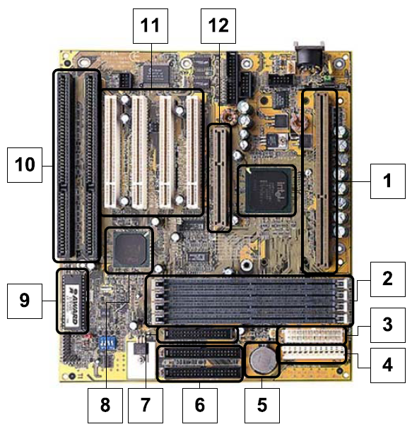

13

|  |  |  |  |
| --- | --- | --- | --- |
| **Número** | **Componente** | **Número** | **Componente** |
| 1 |  | 8 |  |
| 2 |  | 9 |  |
| 3 |  | 10 |  |
| 4 |  | 11 |  |
| 5 |  | 12 |  |
| 6 |  | 13 |  |
| 7 |  |  |  |